Consolidator® Console Equipment Bracket
One Bracket Works For All Three Applications
Part Number: C-EB30-MAO-1P

For~

M/A-COM

Self-Contained
Dash Mount Radio

Flush Mount
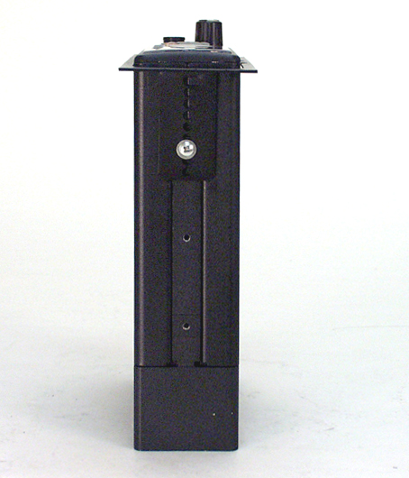
OpenSky® M-803 Mobile Radios & CH-103 Control Head
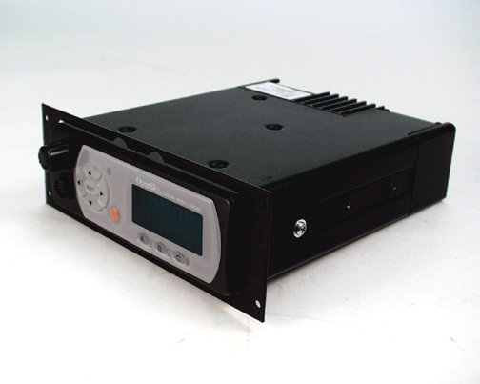

Remote Mount
CH-103 Control Head

Flush Mount
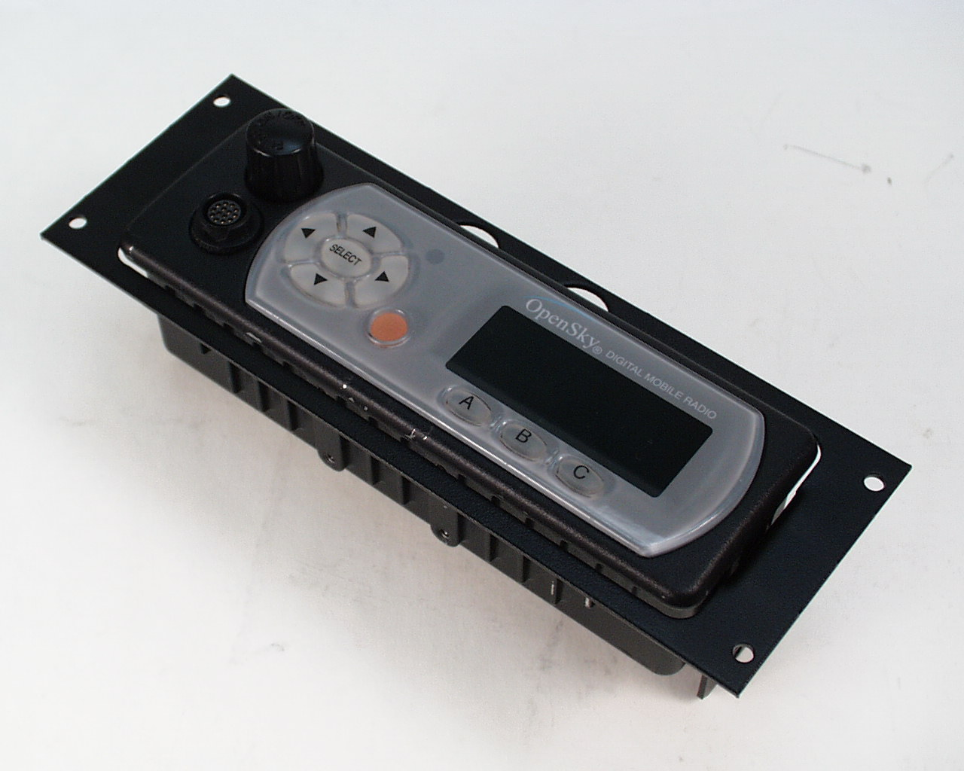
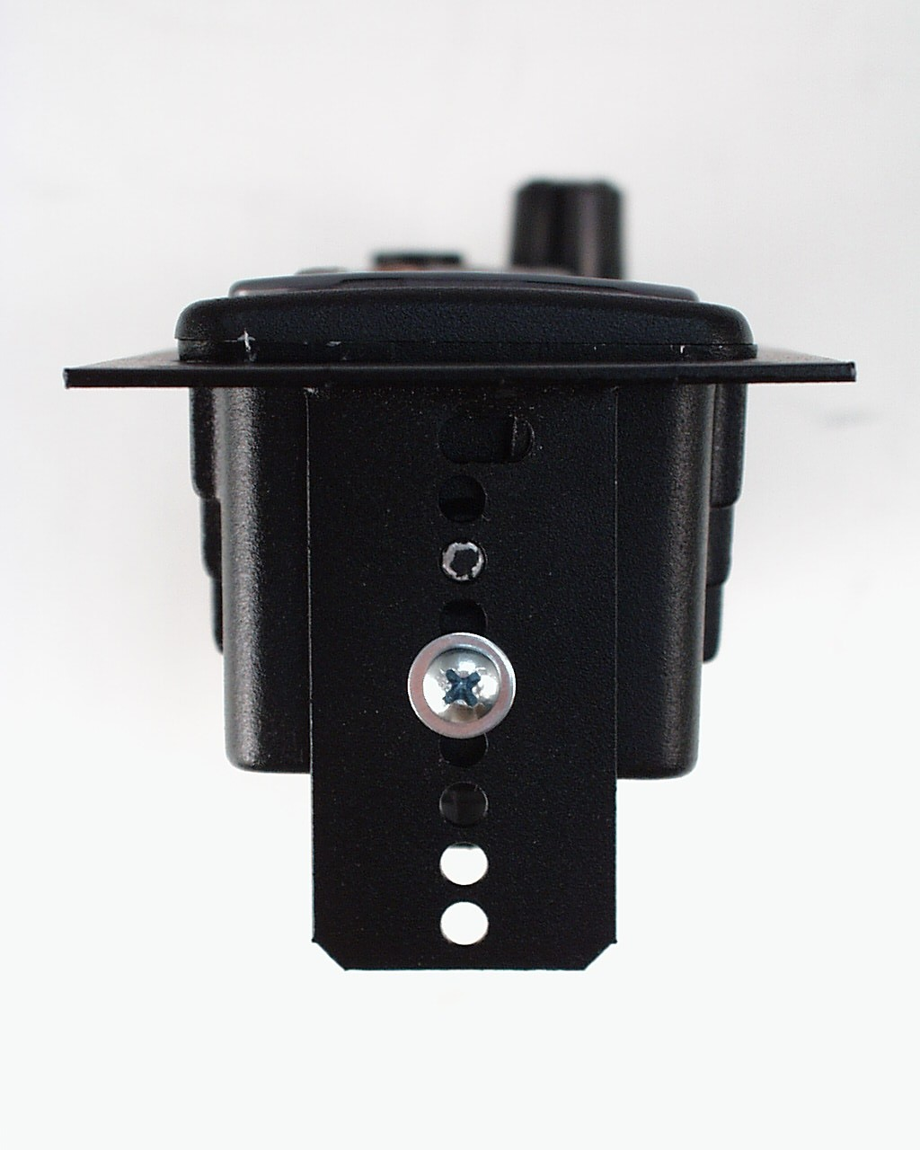
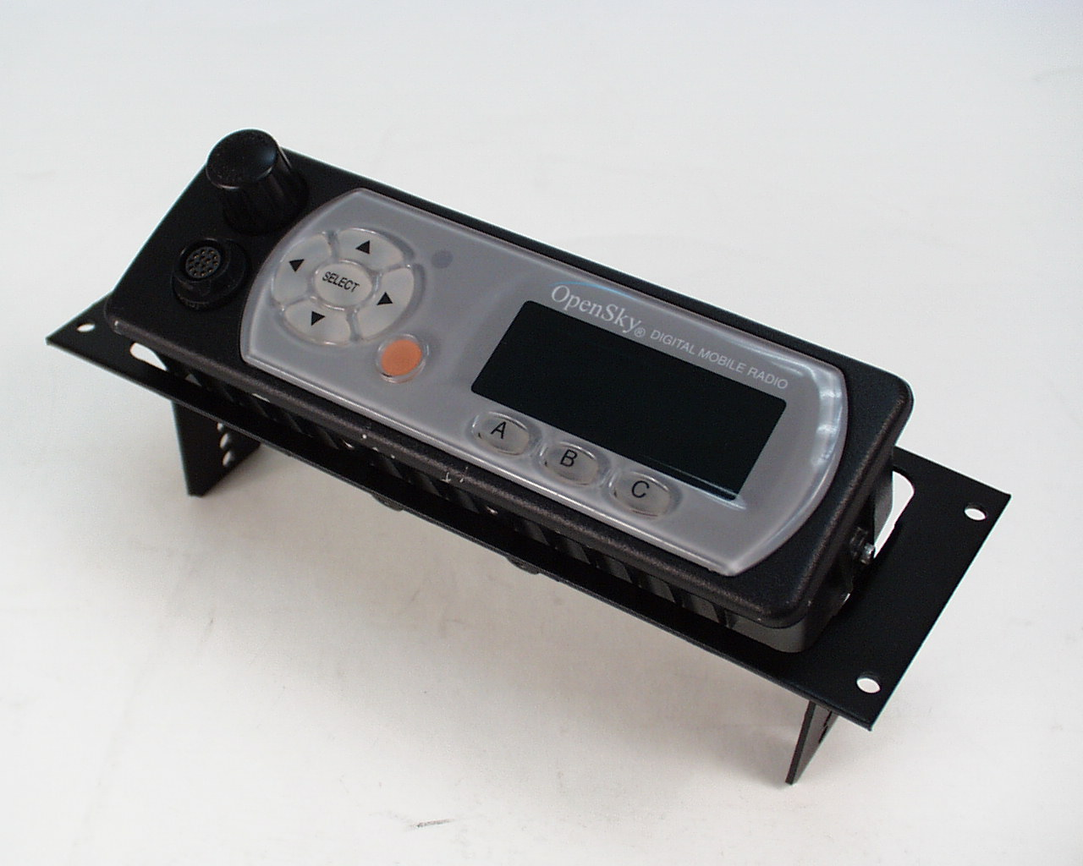
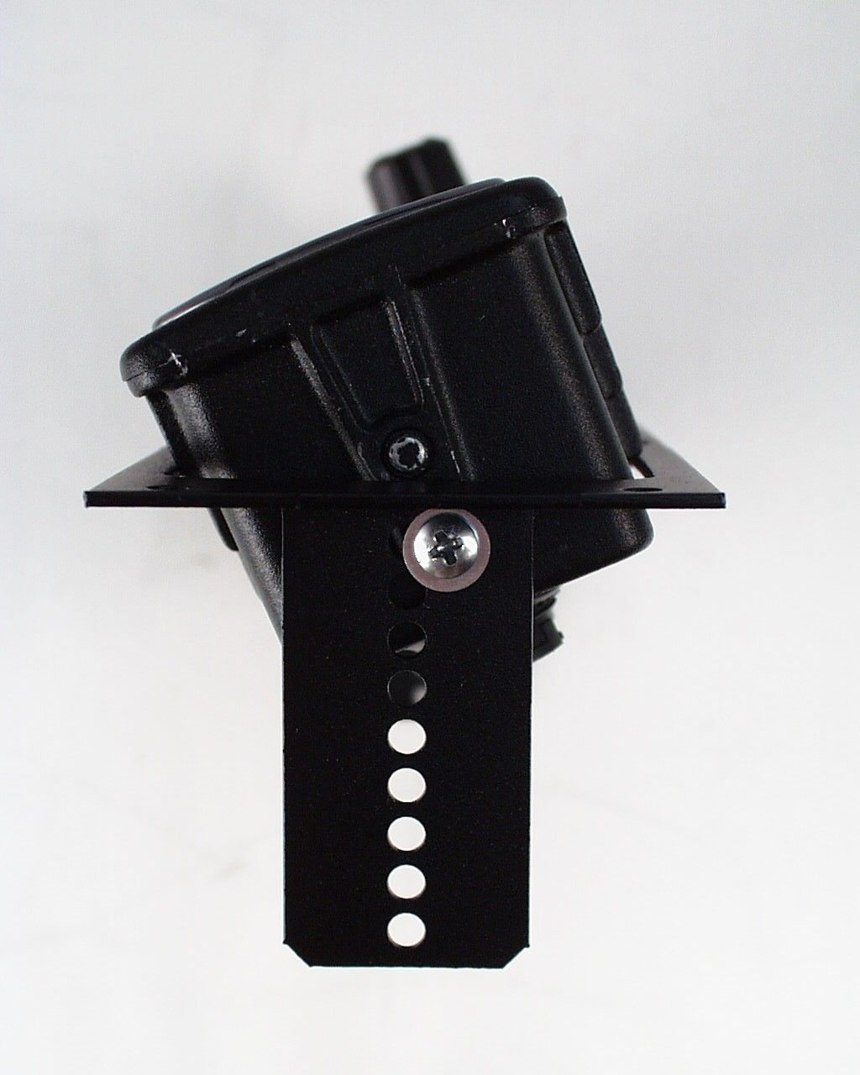

Remote Mount
CH-103 Control Head
20 Degree Angle Mount
/tmp/lo/0000.doc
✰
•


